Se ha creado el proyecto con el nombre FinalCarhuasJ
- Habilitamos la api dataproc
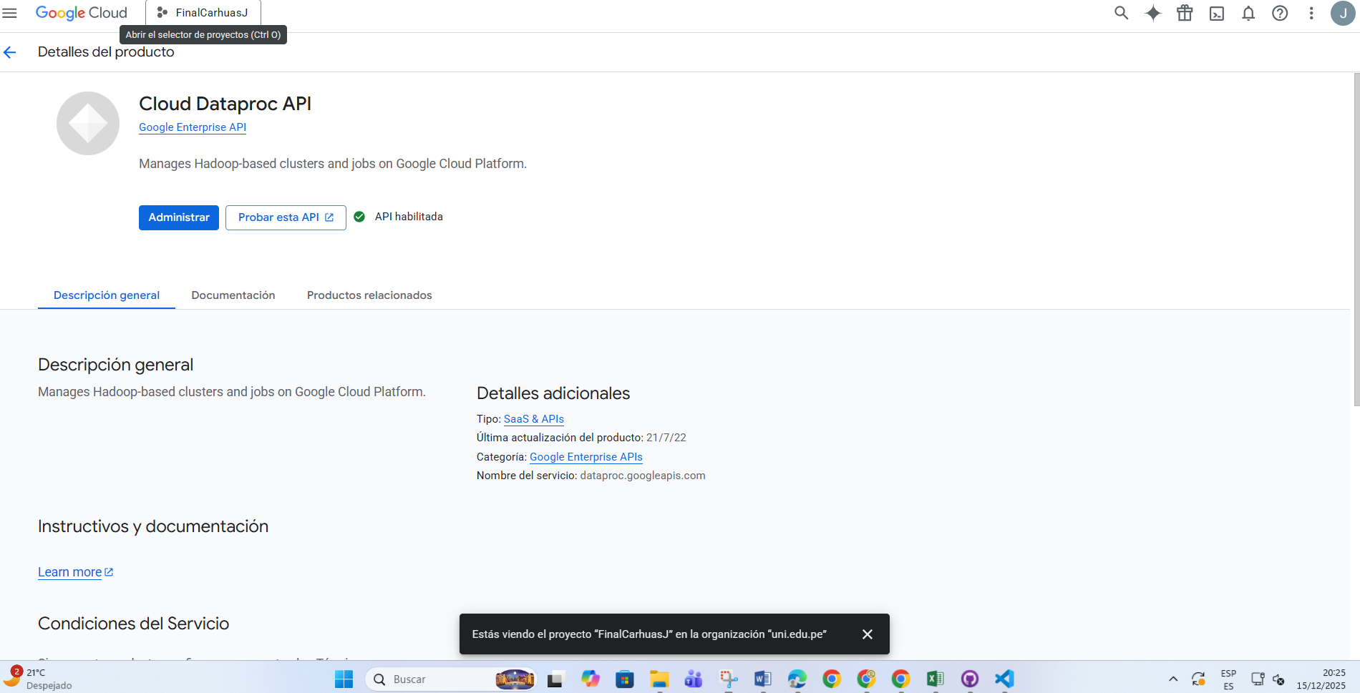 otorgamos acceso
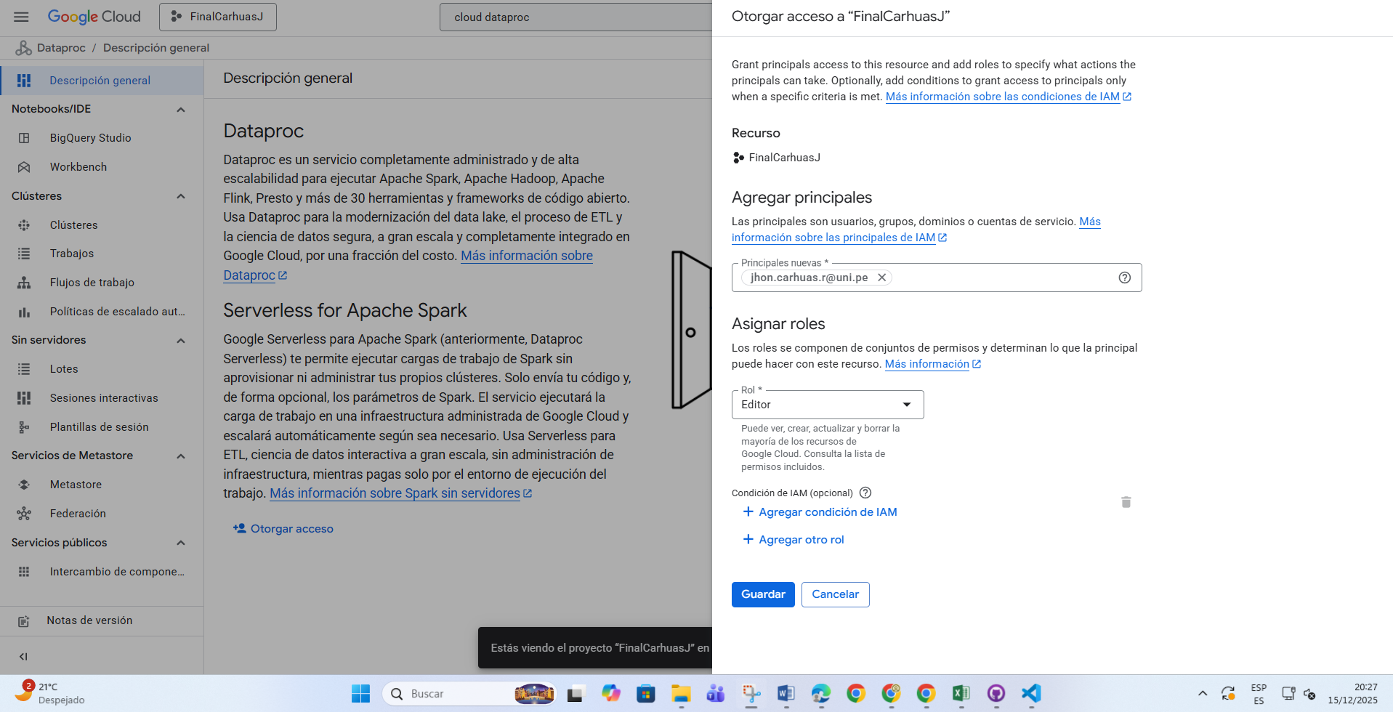
- Creación de bucket
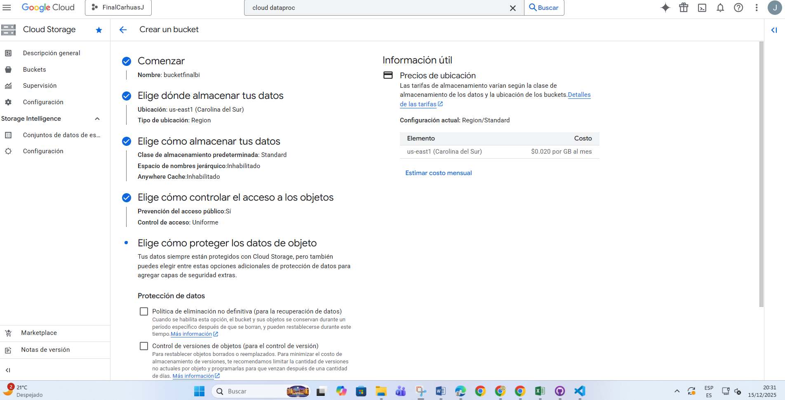

- Creamos las carpetas
- 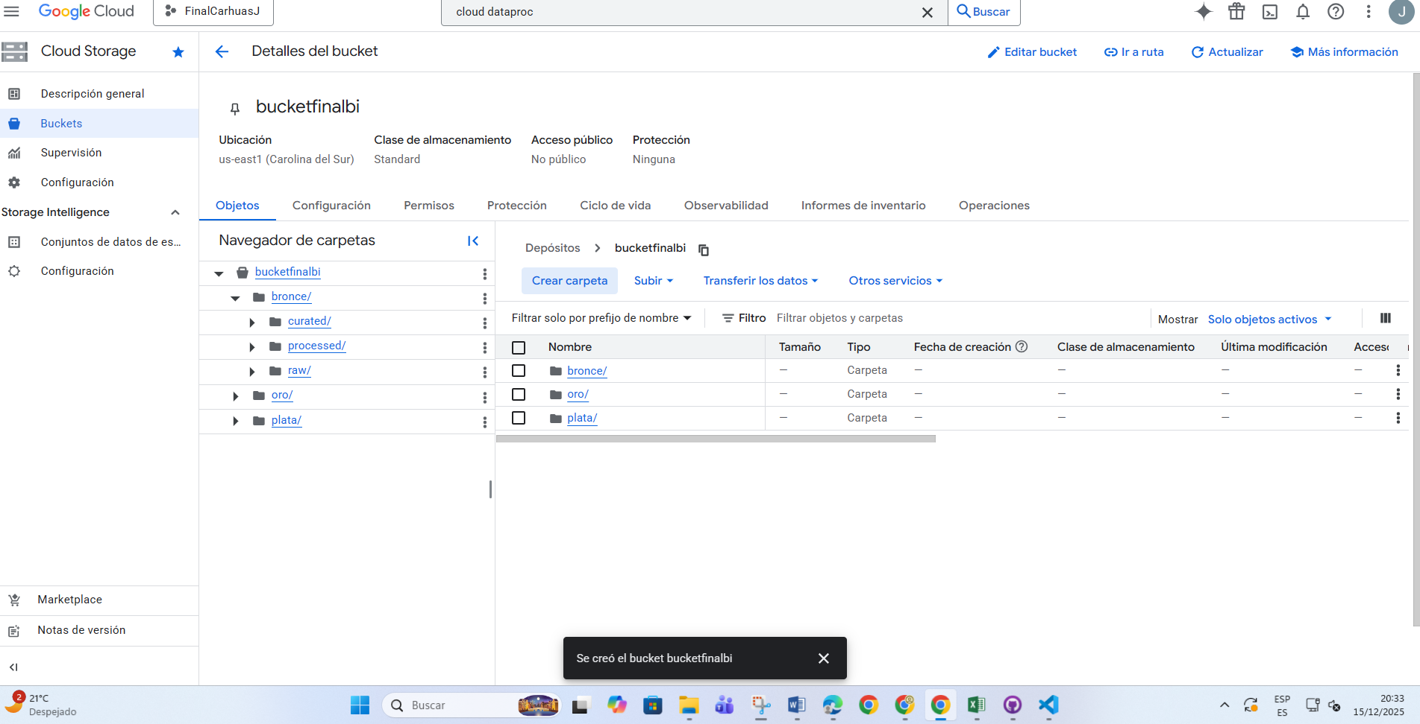subida del archivo
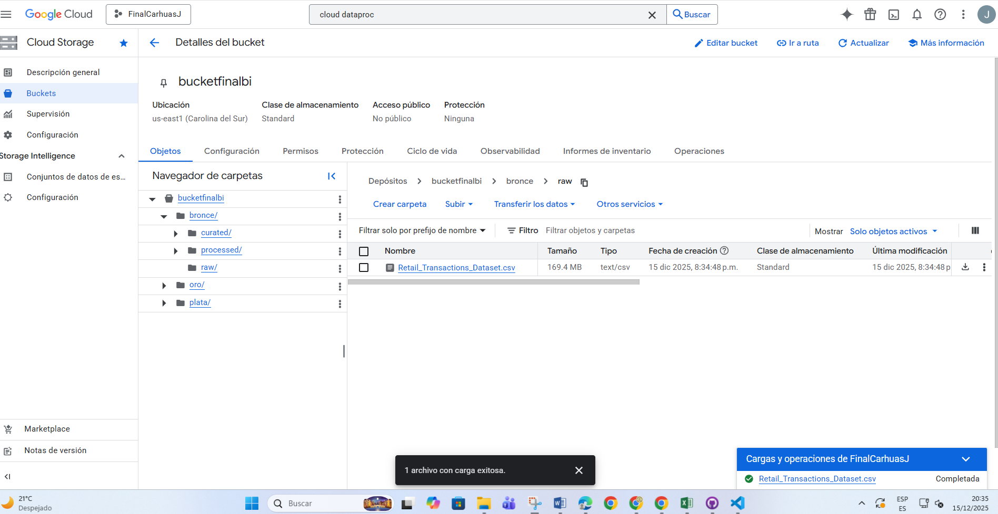
- Se crea el cluster
Rimero
PROJECT=finalcarhuasj
REGION=us-central1
ZONE=us-central1-a
CLUSTER_NAME=cluster-spark-final
IMAGE_VERSION=2.1-debian11
BUCKET_TEMP=bucketfinalbi

gcloud config set project $PROJECT

LUEGO

gcloud dataproc clusters create $CLUSTER_NAME \
--region=$REGION \
--zone=$ZONE \
--image-version=$IMAGE_VERSION \
--enable-component-gateway \
--optional-components=JUPYTER \
--master-machine-type=n1-standard-2 \
--master-boot-disk-size=100GB \
--num-workers=2 \
--worker-machine-type=n1-standard-2 \
--worker-boot-disk-size=100GB \
--bucket=$BUCKET_TEMP \
--project=$PROJECT

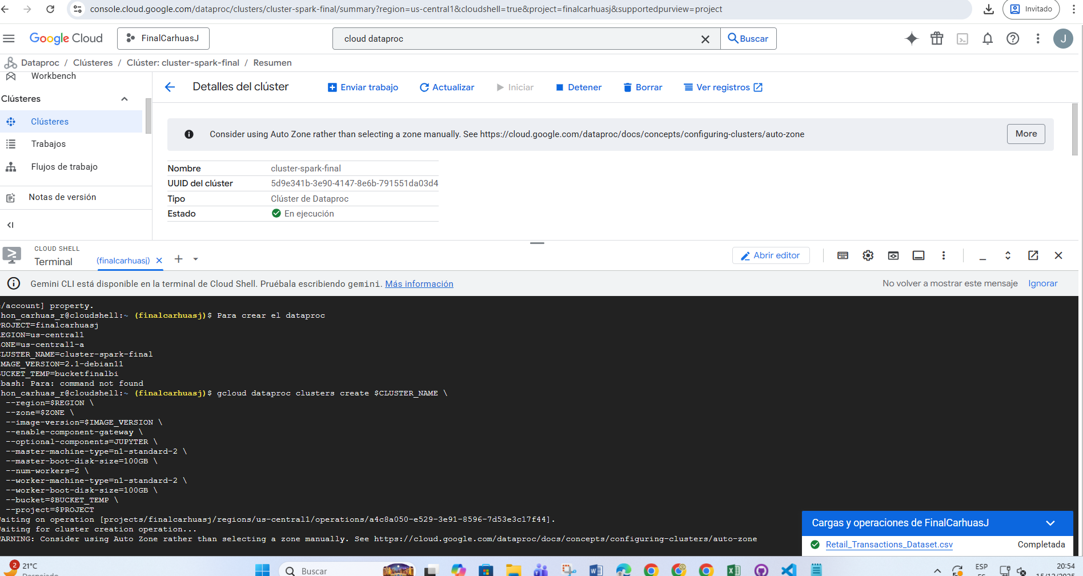
Seleccionamos el cluster - web interface Nos dirigimos a jupiter lab para poder
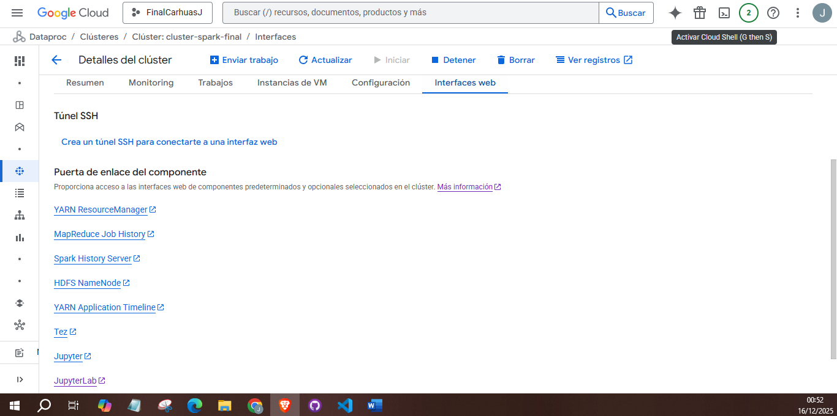
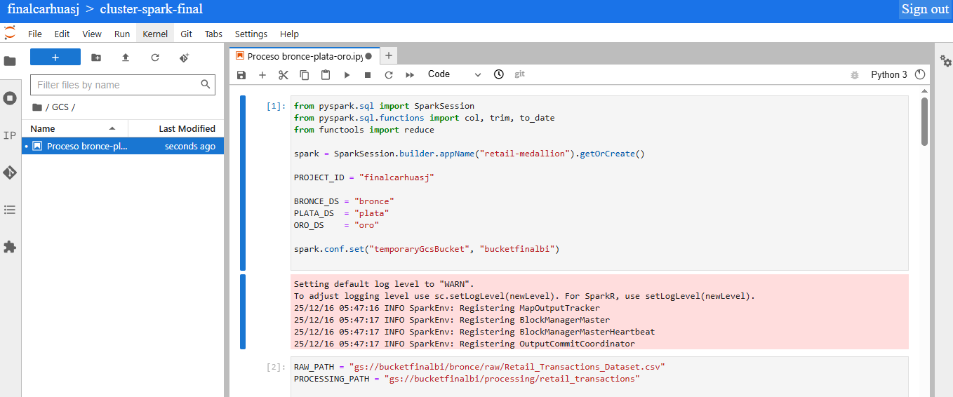
CÓDIGOS CON EVIDENCIAS
- CONFIGURACIÓN GENERAL
from pyspark.sql import SparkSession
from pyspark.sql.functions import col, trim, to_date
from functools import reduce

spark = SparkSession.builder.appName("retail-medallion").getOrCreate()

PROJECT_ID = "finalcarhuasj"

BRONCE_DS = "bronce"
PLATA_DS = "plata"
ORO_DS = "oro"

spark.conf.set("temporaryGcsBucket", "bucketfinalbi")

- RAW → BRONCE
RAW_PATH = "gs://bucketfinalbi/bronce/raw/Retail_Transactions_Dataset.csv"
PROCESSING_PATH = "gs://bucketfinalbi/processing/retail_transactions"

# Leer CSV RAW
df_raw = (
spark.read
.option("header", "true")
.csv(RAW_PATH)
)

# Normalizar strings
for c, t in df_raw.dtypes:
if t == "string":
df_raw = df_raw.withColumn(c, trim(col(c)))

# Eliminar filas totalmente nulas
df_no_nulls = df_raw.dropna(how="all")

# Eliminar duplicados
df_clean = df_no_nulls.dropDuplicates()

# Guardar CSV limpio (processing)
df_clean.coalesce(1).write.mode("overwrite") \
.option("header", "true") \
.csv(PROCESSING_PATH)

# Guardar en BigQuery (Bronce)
(
df_clean.write
.format("bigquery")
.option("table", f"{PROJECT_ID}.{BRONCE_DS}.retail_transactions")
.mode("overwrite")
.save()
)
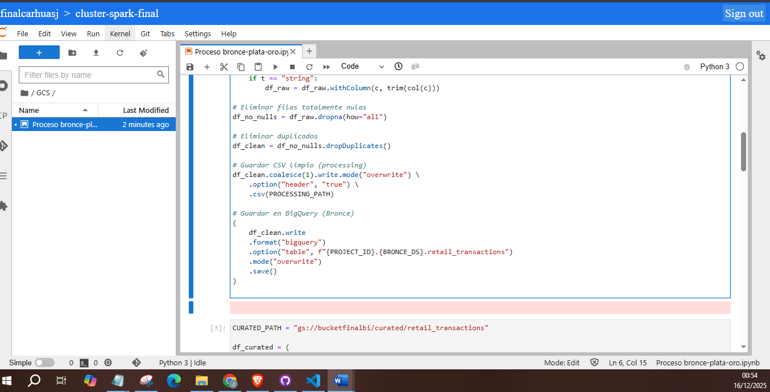
- PROCESSING → CURATED
CURATED_PATH = "gs://bucketfinalbi/curated/retail_transactions"

df_curated = (
df_clean
.withColumn("Date", to_date(col("Date")))
.withColumn("Total_Items", col("Total_Items").cast("int"))
.withColumn("Total_Cost", col("Total_Cost").cast("double"))
.withColumn("Discount_Applied", col("Discount_Applied").cast("boolean"))
)

df_curated.coalesce(1).write.mode("overwrite") \
.option("header", "true") \
.csv(CURATED_PATH)
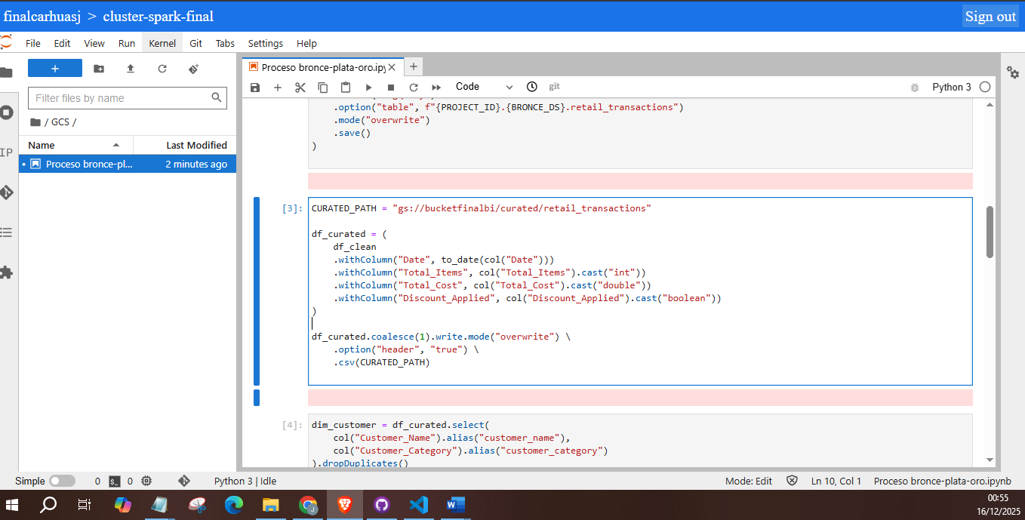

- CURATED → PLATA
dim_customer = df_curated.select(
col("Customer_Name").alias("customer_name"),
col("Customer_Category").alias("customer_category")
).dropDuplicates()

dim_customer.write.format("bigquery") \
.option("table", f"{PROJECT_ID}.{PLATA_DS}.dim_customer") \
.mode("overwrite").save()
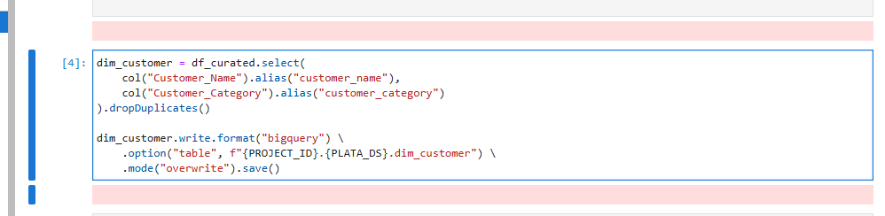

- DIM_PRODUCT
dim_product = df_curated.select(
col("Product").alias("product_name")
).dropDuplicates()

dim_product.write.format("bigquery") \
.option("table", f"{PROJECT_ID}.{PLATA_DS}.dim_product") \
.mode("overwrite").save()
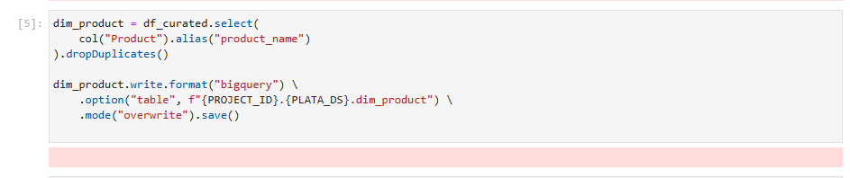
- DIM_CITY
dim_city = df_curated.select(
col("City").alias("city_name")
).dropDuplicates()

dim_city.write.format("bigquery") \
.option("table", f"{PROJECT_ID}.{PLATA_DS}.dim_city") \
.mode("overwrite").save()

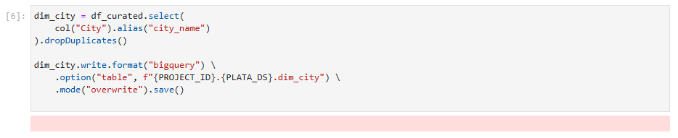
- DIM_TIME
dim_time = df_curated.select(
col("Date").alias("date")
).dropDuplicates()

dim_time.write.format("bigquery") \
.option("table", f"{PROJECT_ID}.{PLATA_DS}.dim_time") \
.mode("overwrite").save()

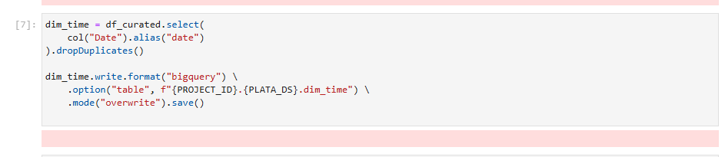

- FACT_TRANSACTION (PLATA)
fact_transaction = df_curated.select(
"Transaction_ID",
"Date",
"Total_Items",
"Total_Cost",
"Discount_Applied"
)

fact_transaction.write.format("bigquery") \
.option("table", f"{PROJECT_ID}.{PLATA_DS}.fact_transaction") \
.mode("overwrite").save()
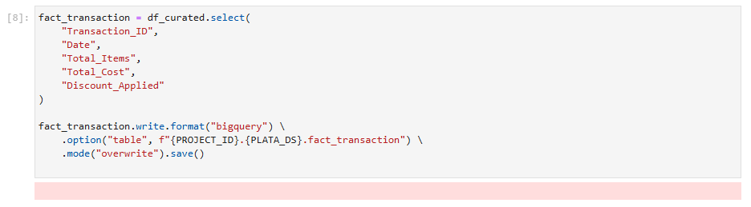

- PLATA → ORO

DIMENSIONES (ORO)
dim_customer_oro = spark.read.format("bigquery") \
.option("table", f"{PROJECT_ID}.{PLATA_DS}.dim_customer") \
.load()

dim_customer_oro.write.format("bigquery") \
.option("table", f"{PROJECT_ID}.{ORO_DS}.dim_customer") \
.mode("overwrite").save()

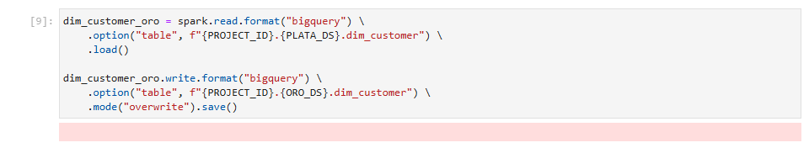
FACT_SALES (ORO)
fact_sales = spark.read.format("bigquery") \
.option("table", f"{PROJECT_ID}.{PLATA_DS}.fact_transaction") \
.load()

fact_sales.write.format("bigquery") \
.option("table", f"{PROJECT_ID}.{ORO_DS}.fact_sales") \
.mode("overwrite").save()

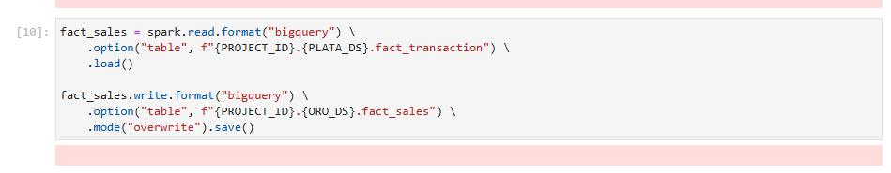

fact_sales.coalesce(1).write.mode("overwrite") \
.option("header", "true") \
.csv("gs://bucketfinalbi/oro/fact_sales")

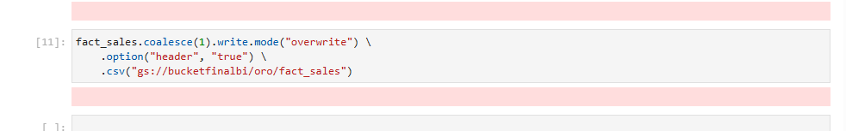

Podemos observar que se cargaron mediante script a los dataset de bronce, plata, y oro, donde en el oro nos salió una dim_customer, con fact_sales
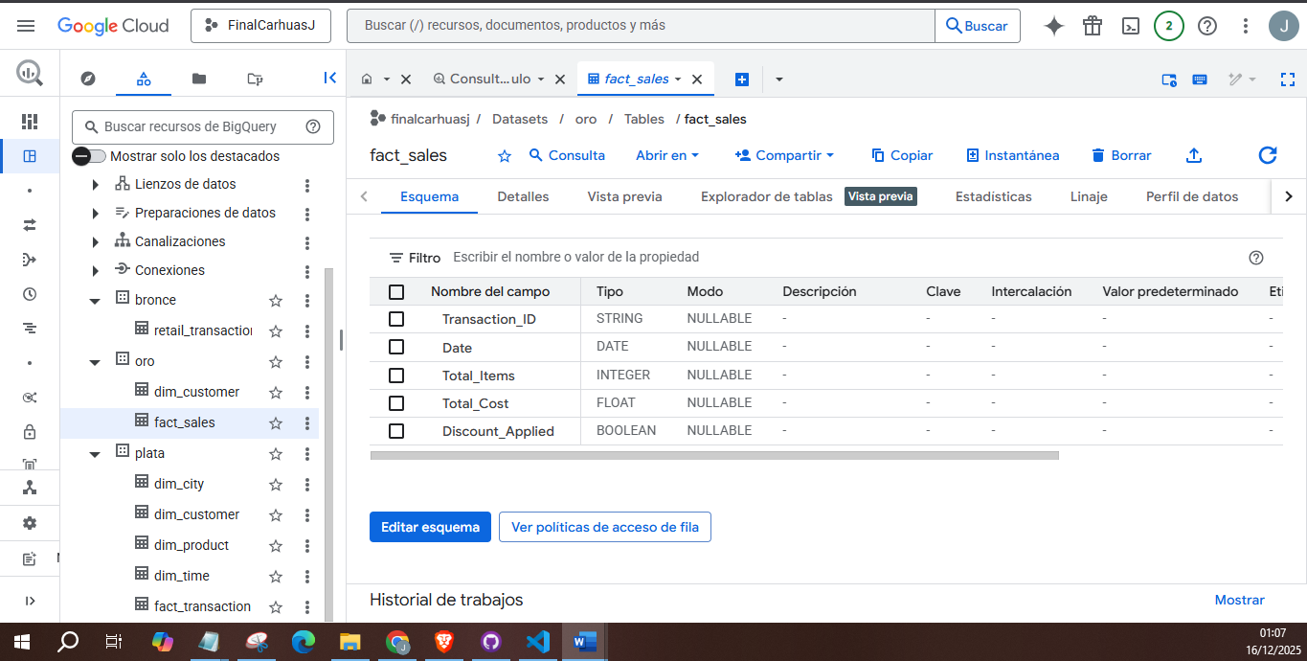

KPIS
- Configuración
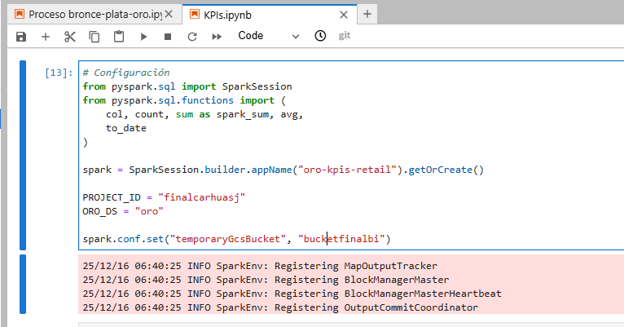

- Leer fact_sales
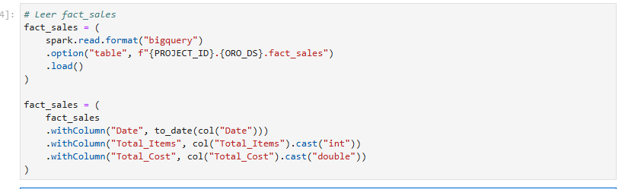

- KPI 1:Ticket promedio (GLOBAL)
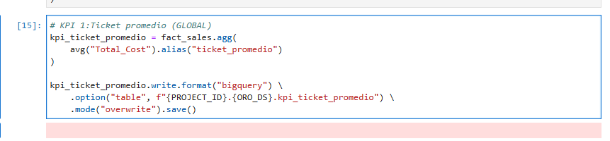
- KPI 2: Frecuencia de compra (por día)
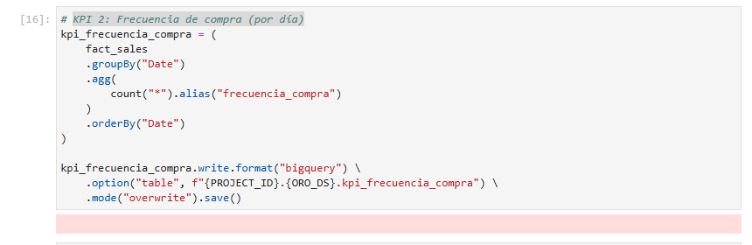
- KPI 3: Ventas diarias
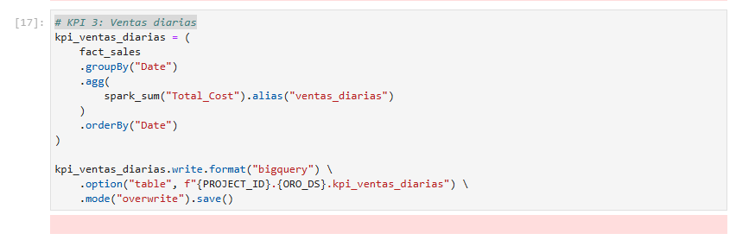
- KPI 4: Promedio de ítems por transacción
